Hexin Liu

Dr. Nick Rosasco

11-28-2022

CS-250-A

UML Diagrams

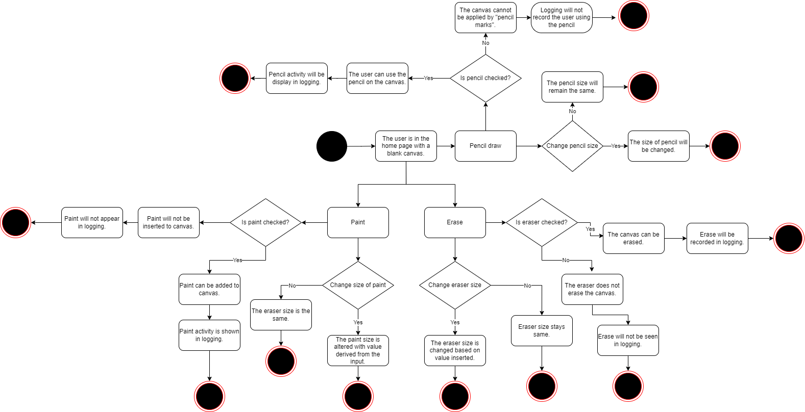

Activity Diagram

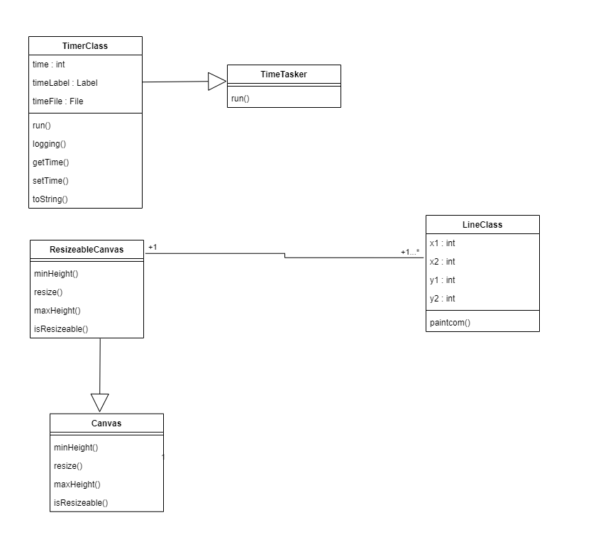

Class Diagram

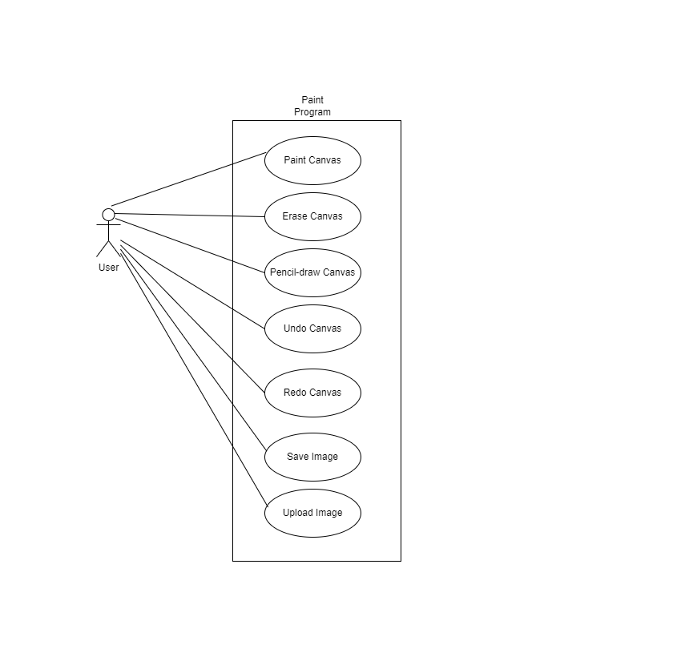

Use Case Diagram

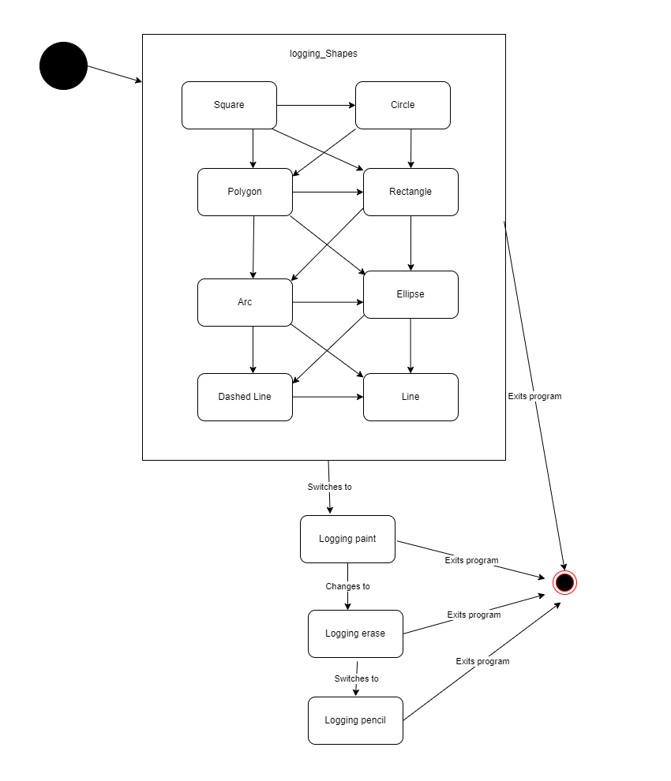

State Diagram

Links to Websites Referred

<https://www.lucidchart.com/pages/uml-activity-diagram>

<https://www.lucidchart.com/pages/uml-class-diagram>

<https://www.lucidchart.com/pages/uml-use-case-diagram>